
San Francisco Bay University

CE450 Fundamentals of Embedded Engineering
Lab 2 LED Driving

Objectives:
The purpose of this exercise is to learn how to drive on-board LEDs in different ways. Student will study Python programming basic concepts on Raspberry Pi board and do hands-on exercise through lab assignments.

Introduction:
This lab is to create a design that causes LEDs on the development board to blink. Through hooking up GPIO port on Raspberry Pi board to LEDs, student could verify their designs.

Equipment:
The equipment you require is as follows:
- Laptop & Raspberry Pi 3 model Board
- SunFounder Super Starter Kit V2.0 for Raspberry Pi

The Laboratory Procedure:
- Hardware connection
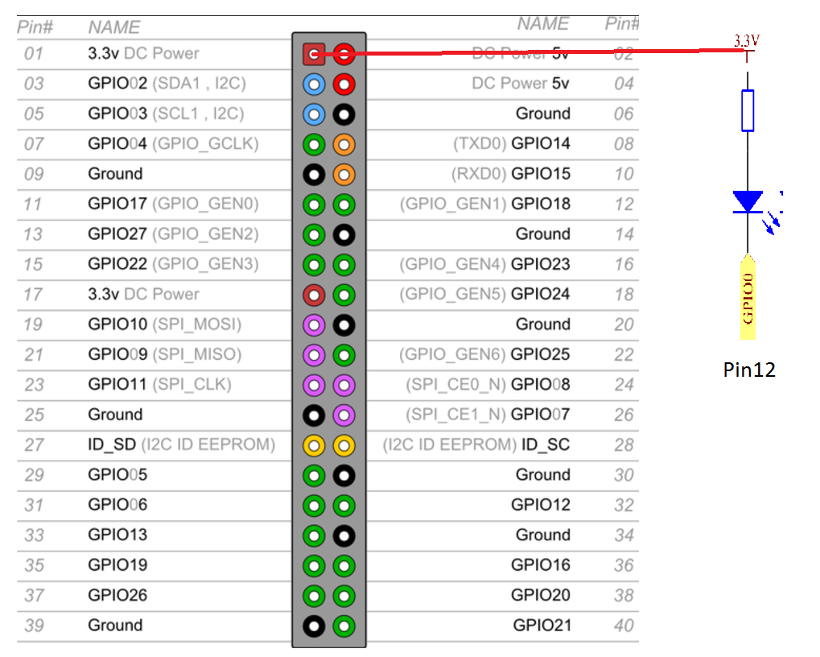
- Control program in Python

import RPi.GPIO as GPIO # RPi.GPIO – func. Lib for gpio port ctrl
import time # import xxxx as y y: alias of xxxx
# time --- built in func in Linux(Rasbian)

LedPin = 12 # later LedPin will be pin 12

def setup(): # port config.
global p # global P
GPIO.setmode(GPIO.BOARD) # Numbers GPIOs by physical location
GPIO.setup(LedPin, GPIO.OUT) # Set LedPin's mode is output
GPIO.output(LedPin, GPIO.LOW) # Set LedPin to low(0V) to switch on LED

p = GPIO.PWM(LedPin, 1000) # set Frequece to 1KHz
p.start(0) # Duty Cycle = 0%; DC(Length of Voltage Hi)
# p.start(20)=20%

def loop():
while(True): # forever loop
for dc in range(0, 101, 4): # Increase duty cycle: 0~100 step=4
p.ChangeDutyCycle(dc) # Change duty cycle
time.sleep(0.05) # time.sleep(sec)
time.sleep(1)
for dc in range(100, -1, -4): # Decrease duty cycle: 100~0
p.ChangeDutyCycle(dc)
time.sleep(0.05)
time.sleep(1)

def destroy():
p.stop()
GPIO.output(LedPin, GPIO.HIGH) # turn off all leds
GPIO.cleanup()

setup()
try:
loop()
except KeyboardInterrupt: # When 'Ctrl+C' is pressed, the child program destroy() will be executed.
destroy()

*Note: More Functions related to PWM in GPIO module
https://sourceforge.net/p/raspberry-gpio-python/wiki/PWM/

*Note: Program reference and running command
https://learn.sunfounder.com/lesson-1-blinking-led-9/
https://learn.sunfounder.com/category/super-kit-v3-0-for-raspberry-pi/

The Laboratory Assignments:

- Design program to blink one LED and shift back and forth among 8 LEDs.
- Make 2 LEDs at the two ends of 8 LEDs on the board blink and move in different directions and back.
- Make 2 LEDs in the center blink in different directions and move back.

*Note: take the program and hardware connection as reference at
https://learn.sunfounder.com/lesson-3-flowing-led-lights/

